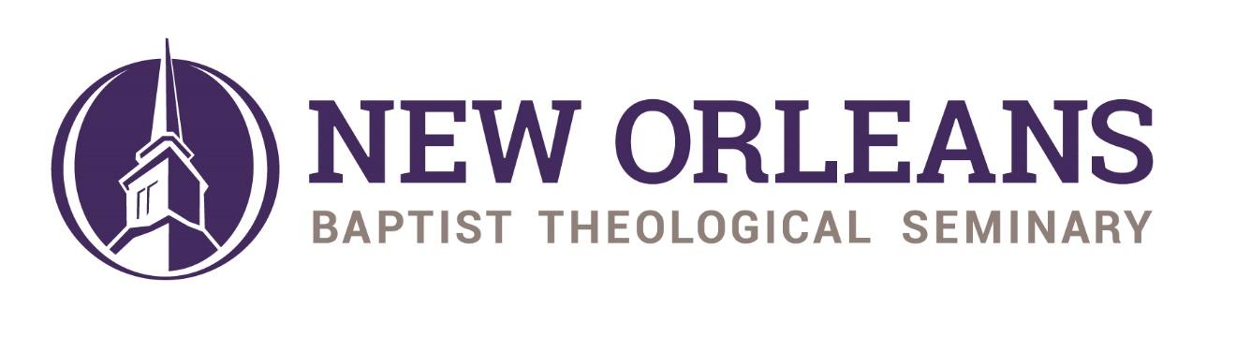
BIOGRAPHICAL INFORMATION

NAME: Charles S. "Chuck" Kelley Jr.
ADDRESS: 3939 Gentilly Blvd. – Box 619
New Orleans, LA 70126

PHONE: Home: (504) 283-0804
Cell: (504) 432-0169

PRESENT POSITIONS:
New Orleans Baptist Theological Seminary (since 1983)
President Emeritus and
Distinguished Research Professor of Evangelism (since 2019)
Innovative Evangelism (since 1978)
Founder and Director
Itinerant Preacher and Evangelist
Writer and Researcher in Evangelism
Evangelism Blogger (since 2019 at www.drchuckkelley.com)
Evangelism Consultant (since 1983)

FAMILY: Wife - Rhonda Harrington Kelley, Ph.D. Adjunct Professor of Women’s Ministry, Christian Speaker, Writer, and Associate Director of Innovative Evangelism. Married, June 21, 1974

ORDAINED TO MINISTRY: February 2, 1972

EDUCATION:
Th.D. (Preaching) New Orleans Baptist Theological Seminary, 1983
M.Div. (Biblical Studies) New Orleans Baptist Theological Seminary, 1978
B.A. (Philosophy) Baylor University, 1974

MINISTRY EXPERIENCE:
President Emeritus, New Orleans Baptist Theological Seminary, 2019-present
Chancellor, New Orleans Baptist Theological Seminary, 2018-2019
President, New Orleans Baptist Theological Seminary, 1996-2019
Professor of Evangelism, New Orleans Baptist Theological Seminary, 1983-
present
Roland Q. Leavell Professor of Evangelism, New Orleans Baptist Theological
Seminary, 1989-1996
Director of Leavell Center for Evangelism & Church Growth, New Orleans
Baptist Theological Seminary, 1993-1996
Chairman of the Division of Pastoral Ministries, New Orleans Baptist Theological
Seminary, 1993-1995
Itinerant Evangelist, Innovative Evangelism, Inc. 1975 - present
Minister of Outreach, Ministry of Bob Harrington, New Orleans, LA, 1975-76
Assistant Director, Collegiate Ministry, Baylor University, Waco, TX, 1972-75
Pastor, Ireland Baptist Church, Ireland, TX, 1971-72

DENOMINATIONAL SERVICE:
Member of SBC Council of Seminary Presidents, 1996-2019
Member of SBC Great Commission Council, 1996-2019
Member of SBC Task Force on Baptist Faith and Message, 2000
Member of SBC Committee on Resolutions, 1993
Member of SBC Committee on Boards, 1986

PUBLICATIONS:
BOOKS:
Fuel the Fire: Lessons from the History of Southern Baptist Evangelism.
Nashville, TN: Broadman and Holman Press, 2018.

The Baptist Faith and Message (an interactive Bible study) by Charles S. Kelley, Jr., Richard Land, and R. Albert Mohler. Nashville, TN: Broadman and Holman Press, 2007.

Evangelism and Church Growth A Practical Encyclopedia by Dr. Elmer Towns,
general ed. Ventura, CA: Regal Books, 1995 (served on Editorial
Committee).

"How to Get A Piece of the Power" in 50 Great Soul-Winning Sermons, compiled
by Jack R. Smith (1994).

"Training for Evangelism" in Evangelism Today and Tomorrow, edited by
Charles Chaney and Granville Watson (1993).

How Did They Do It? The Story of Southern Baptist Evangelism, Insight Press
(October 1992).

Show Me the Way, Convention Press (1991).

EVANGELISM TRAINING MATERIAL:
Here's Hope Roman Road Witnessing Tract Home Mission Board, Publisher
(1994).

Here's Hope Roman Road Witness Training Program Home Mission Board,
Publisher (1994).

Here's Hope Roman Road Witness Training Video Home Mission Board,
Publisher (1994).

"Learning to Share My Faith," A Witness Training Module Baptist Sunday
School Board, Publisher (1990, 1994).

“Thank You” Gospel Tract, Innovative Evangelism, 1981.

“Is God a Stranger to You” Gospel Tract, Innovative Evangelism, 1980.

ARTICLES:
“Leadership Lessons from Another Catastrophe,” Resource of the Illinois Baptist State Association (Summer 2020).

"Involving People in Your Sermons," Church Administration (January,
1995).

"Reaching the Children of the Boomers," Youth Ministry Update (January, 1992).

"Baby Boomers: A Pastor's Bibliography," The Theological Educator (Spring, 1992).

"Ten of My Top Ten," Evangelism (February, 1991).

News to Lost Adults," Adult Leadership (October, 1990).

"A Theological-Historical Look at Revivalism in the SBC," Search (Spring, 1990).

"Issues in Evangelism," The Theological Educator (Spring, 1990).

"Training in Evangelism: How to Select & Design a Program," Evangelism (August, 1989).

"Theology of Excellence," The Theological Educator (Spring, 1986).

"My Calling: Evangelism" in How God Called, compiled by Alice Magill
(1986).

DENOMINATIONAL CURRICULUM:
Explore the Bible, served as General Editor, Winter 2018-19 Curriculum;
Genesis 25-50

Adult Leadership:
"The Witnessing Muscle," Adult Leadership (September, 1991).

"What Is Your Story?" Adult Leadership (August, 1991).

"Taking Steps to Meet Jesus," Adult Leadership (July, 1991).

"Sharing the Gospel with Our Teens," Adult Leadership (July, 1991).

"Telling Our Children," Adult Leadership (June, 1991).

"Mapping the Way," Adult Leadership (May, 1991).

"The ABC's of Salvation," Adult Leadership (April, 1991).

"Working Together," Adult Leadership (April, 1991).

"Is God a Stranger to You?" Adult Leadership (February, 1991).

"Introducing God," Adult Leadership (February, 1991).

"Your Secret Ally," Adult Leadership (January, 1991).

"A Tool for Witnessing," Adult Leadership (December, 1990).

"Begin with Prayer," Adult Leadership (November, 1990).

"Highway to Heaven," Adult Leadership (October, 1990).

"Facing the Challenge: Telling the Good News,” Adult Leadership (September, 1990).

Baptist Youth:
"A Transformed Life-style," Baptist Youth (April, May, June, 1986).

"Relating to Others," Baptist Youth (April, May, June, 1986).

"Keeping the Word," Baptist Youth (April, May, June, 1986).

"From Milk to Meat," Baptist Youth (April, May, June, 1986).

AFFILIATIONS:
New Orleans Baptist Theological Seminary Foundation Board
Evangelical Theological Seminary
Conservative Baptist Network

HONORS:
Engage – Tools for Contemporary Evangelism: A Festschrift in Honor of
Dr. Charles S. Kelley, Jr. New Orleans, LA: New Orleans Baptist Theological Seminary, 2019 (essays on evangelism written by faculty and doctoral students of NOBTS).
Distinguished Alumnus of New Orleans Baptist Theological Seminary, 2016
Doctor of Letters (honorary) from William Carey University
Outstanding Young Man of America, 1979
ODK Men’s National Honorary Leadership Society, Baylor University, 1973-74
Who’s Who in American Colleges and Universities, 1972-73
First Runner-Up, National High School Christian Athlete of the Year for the Fellowship of Christian Athletes, 1970
Student Body President, Forest Park High School, 1969-70
Who’s Who in American High Schools, 1970
Outstanding Teenager of America, 1970
Captain, Fellowship of Christian Athletes Huddle Group, Forest Park High School, 1970

